1st chart - BAR "Skin Cancer on Body"

# Below bar chart shows the total instances for each area of the body that have been effected by skin cancer.

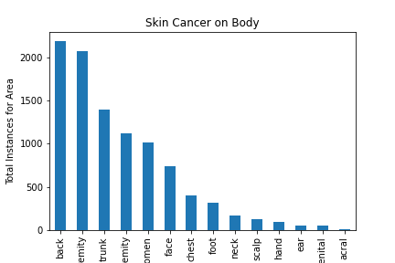

2nd chart - PIE "% of Age Groups Effected"

# Below pie chart shows the age groups effected by skin cancer broken down by percentiles.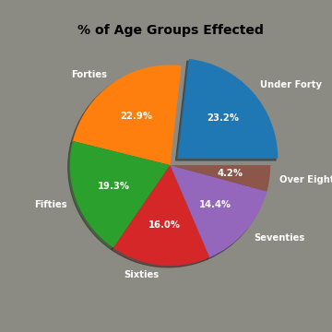

3rd chart - BARH "Localization vs. Age Group"

# Below horizontal bar chart shows the area of the body grouped by age decade.

